Linking Pages Activity

Fill in the Blank with the correct URL or file folder name for this code on the INDEX PAGE

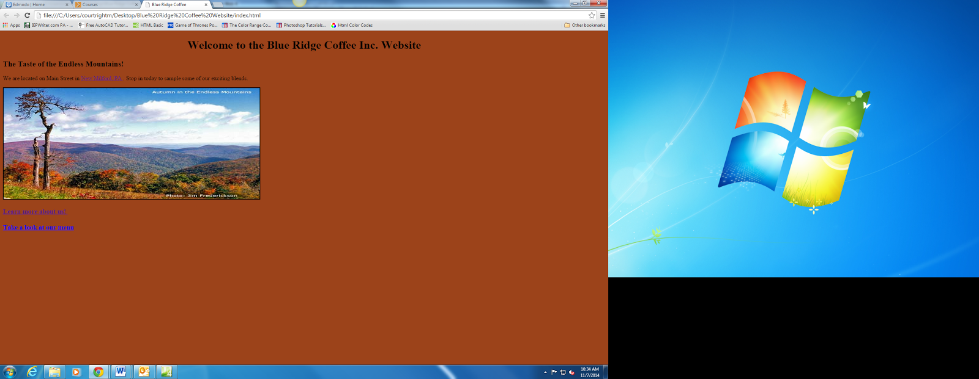

1.) Link text to the About page by filling in the correct URL

<a href="about/___________ "> Learn more about us! </a>

2.) Place the correct folder location in the empty space

<a href="__________/about.html"> Learn more about us! </a>

3.) Link text to the menu page by filling in the correct URL

<a href="menu/__________ ">Take a look at our menu </a>

4.) Place the correct folder location in the empty space

<a href="________/menu.html ">Take a look at our menu </a>

5.) Why must you put the folder before the URL if you want to pages to link together?

About Page

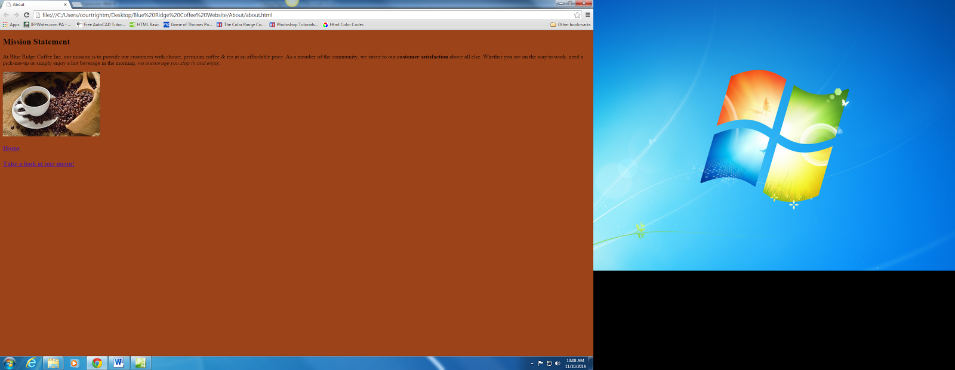

6.) Link text to the Index (or Home) page by filling in the blank:

<a href="../_________ "> Home </a>

7.) Place the correct folder location in the empty space:

<a href="______/index.html"> Home </a>

8.) Link text to the menu page by filling in the correct URL

<a href="../menu/___________ "> Take a look at our menu! </a>

9.) Place the correct folder location in the empty space

<a href="____/______/menu.html"> Take a look at our menu! </a>

10.) How is linking the pages from the about page different than linking from the Index page?